**Introduction**

In this lab, you’ll learn how to install and uninstall applications in Linux.

You’ll use Linux commands in the Bash shell to complete this lab.

You’ll also use the Advanced Package Tool (APT) package manager to install and uninstall the Suricata and tcpdump applications.

The virtual machine you access in this lab has a Debian-based distribution of Linux running, and that works with the APT package manager.

**Tasks**

You have multiple tasks in this lab:

* **Confirm APT is installed in Bash**

Type apt after the command-line prompt and press ENTER

* **Install Suricata with APT**
  1. Use the APT package manager to install the Suricata application.

Type sudo apt install suricata after the command-line prompt and press ENTER.

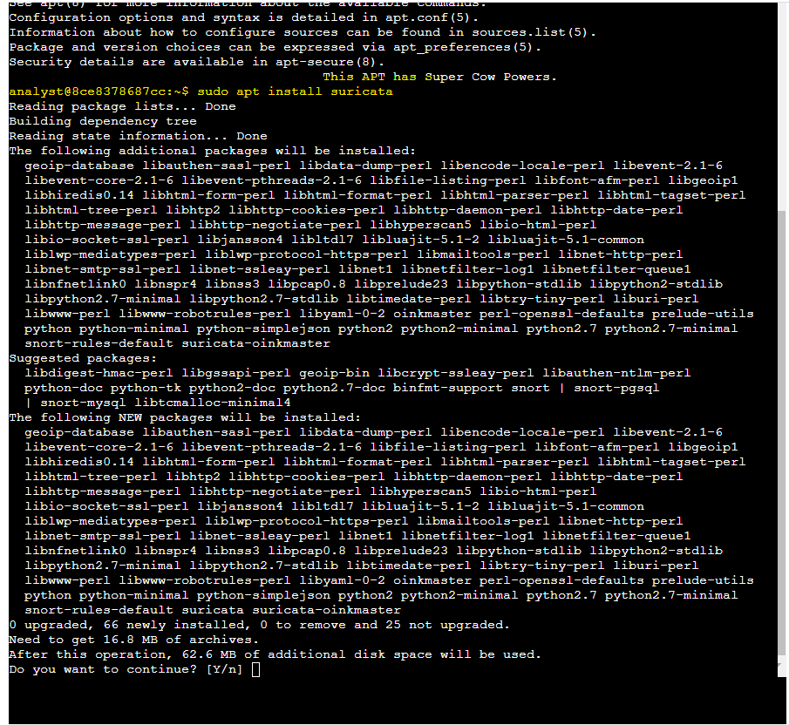

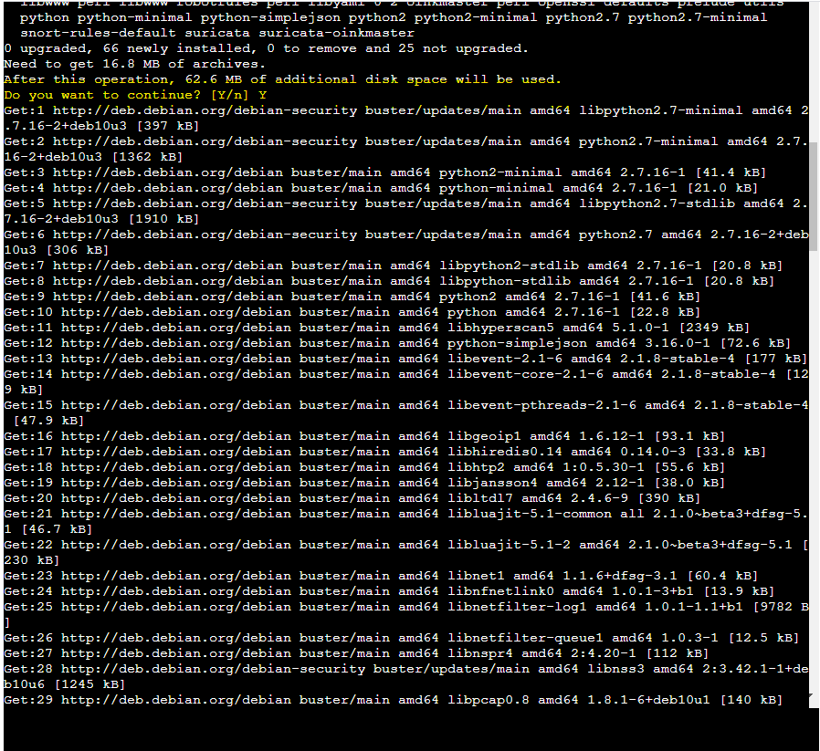

* 1. Verify that Suricata is installed by running the newly installed application.

Type suricata after the command-line prompt and press ENTER.

* **Uninstall Suricata with APT**
  1. Use the APT package manager to uninstall Suricata.

Type sudo apt remove suricata after the command-line prompt and press ENTER.

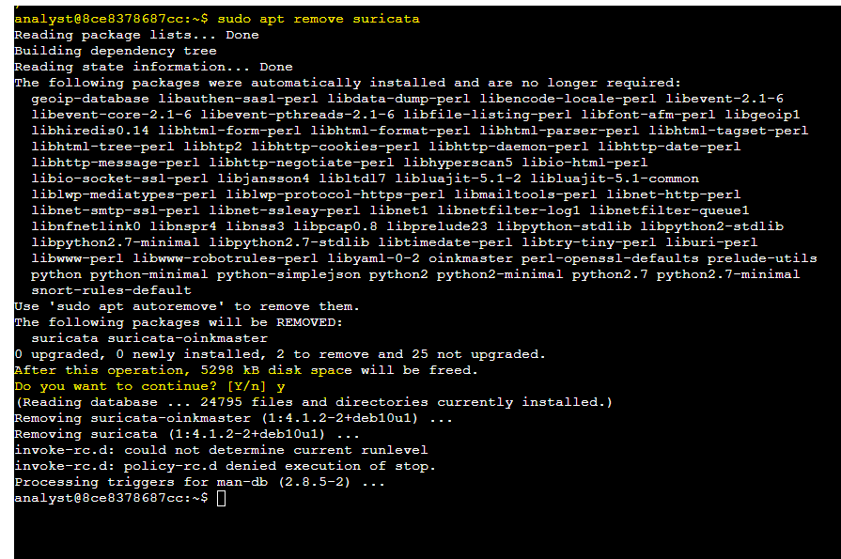

* 1. Verify that Suricata has been uninstalled by running the application command again.

Type suricata after the command-line prompt and press ENTER.



* **Install tcpdump with APT**
  1. Use the APT package manager to install the tcpdump application.

Type sudo apt install tcpdump after the command-line prompt and press ENTER.

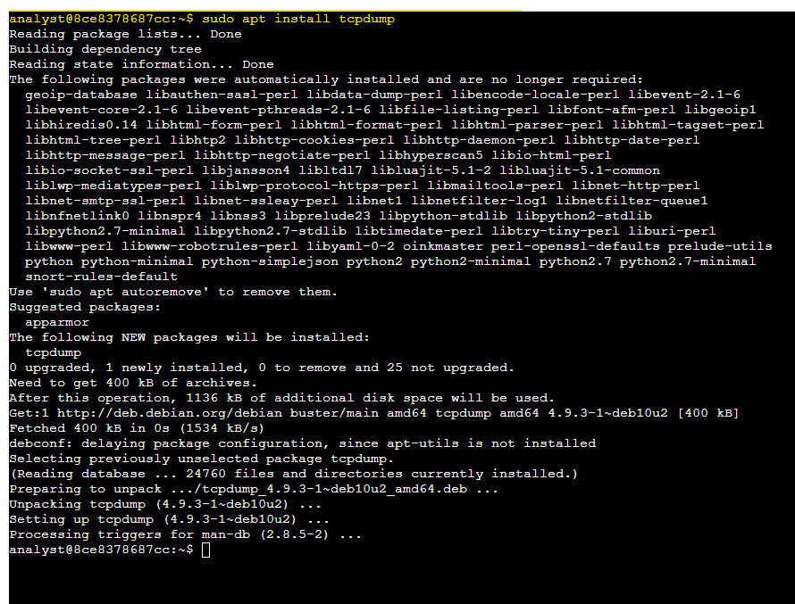

* 1. Verify that tcpdump is installed by running the newly installed application.

Type sudo tcpdump after the command-line prompt and press ENTER.

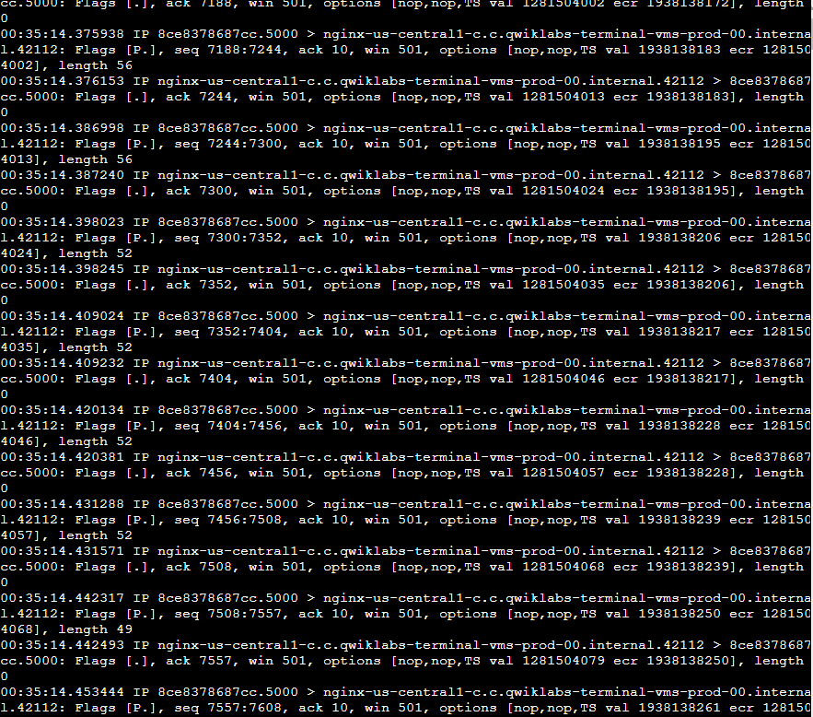

* **List the installed applications**
  1. Use the APT package manager to list all installed applications.

Type apt list --installed after the command-line prompt and press ENTER.

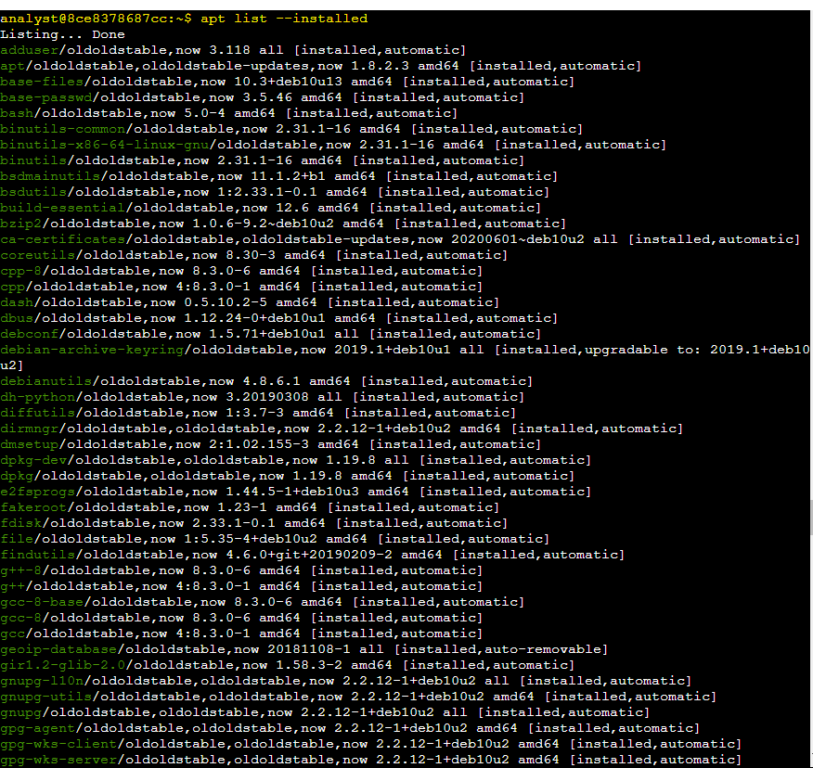

* 1. Search through the list to find the tcpdump application you installed.  
     I used apt list --installed | grep tcpdump

